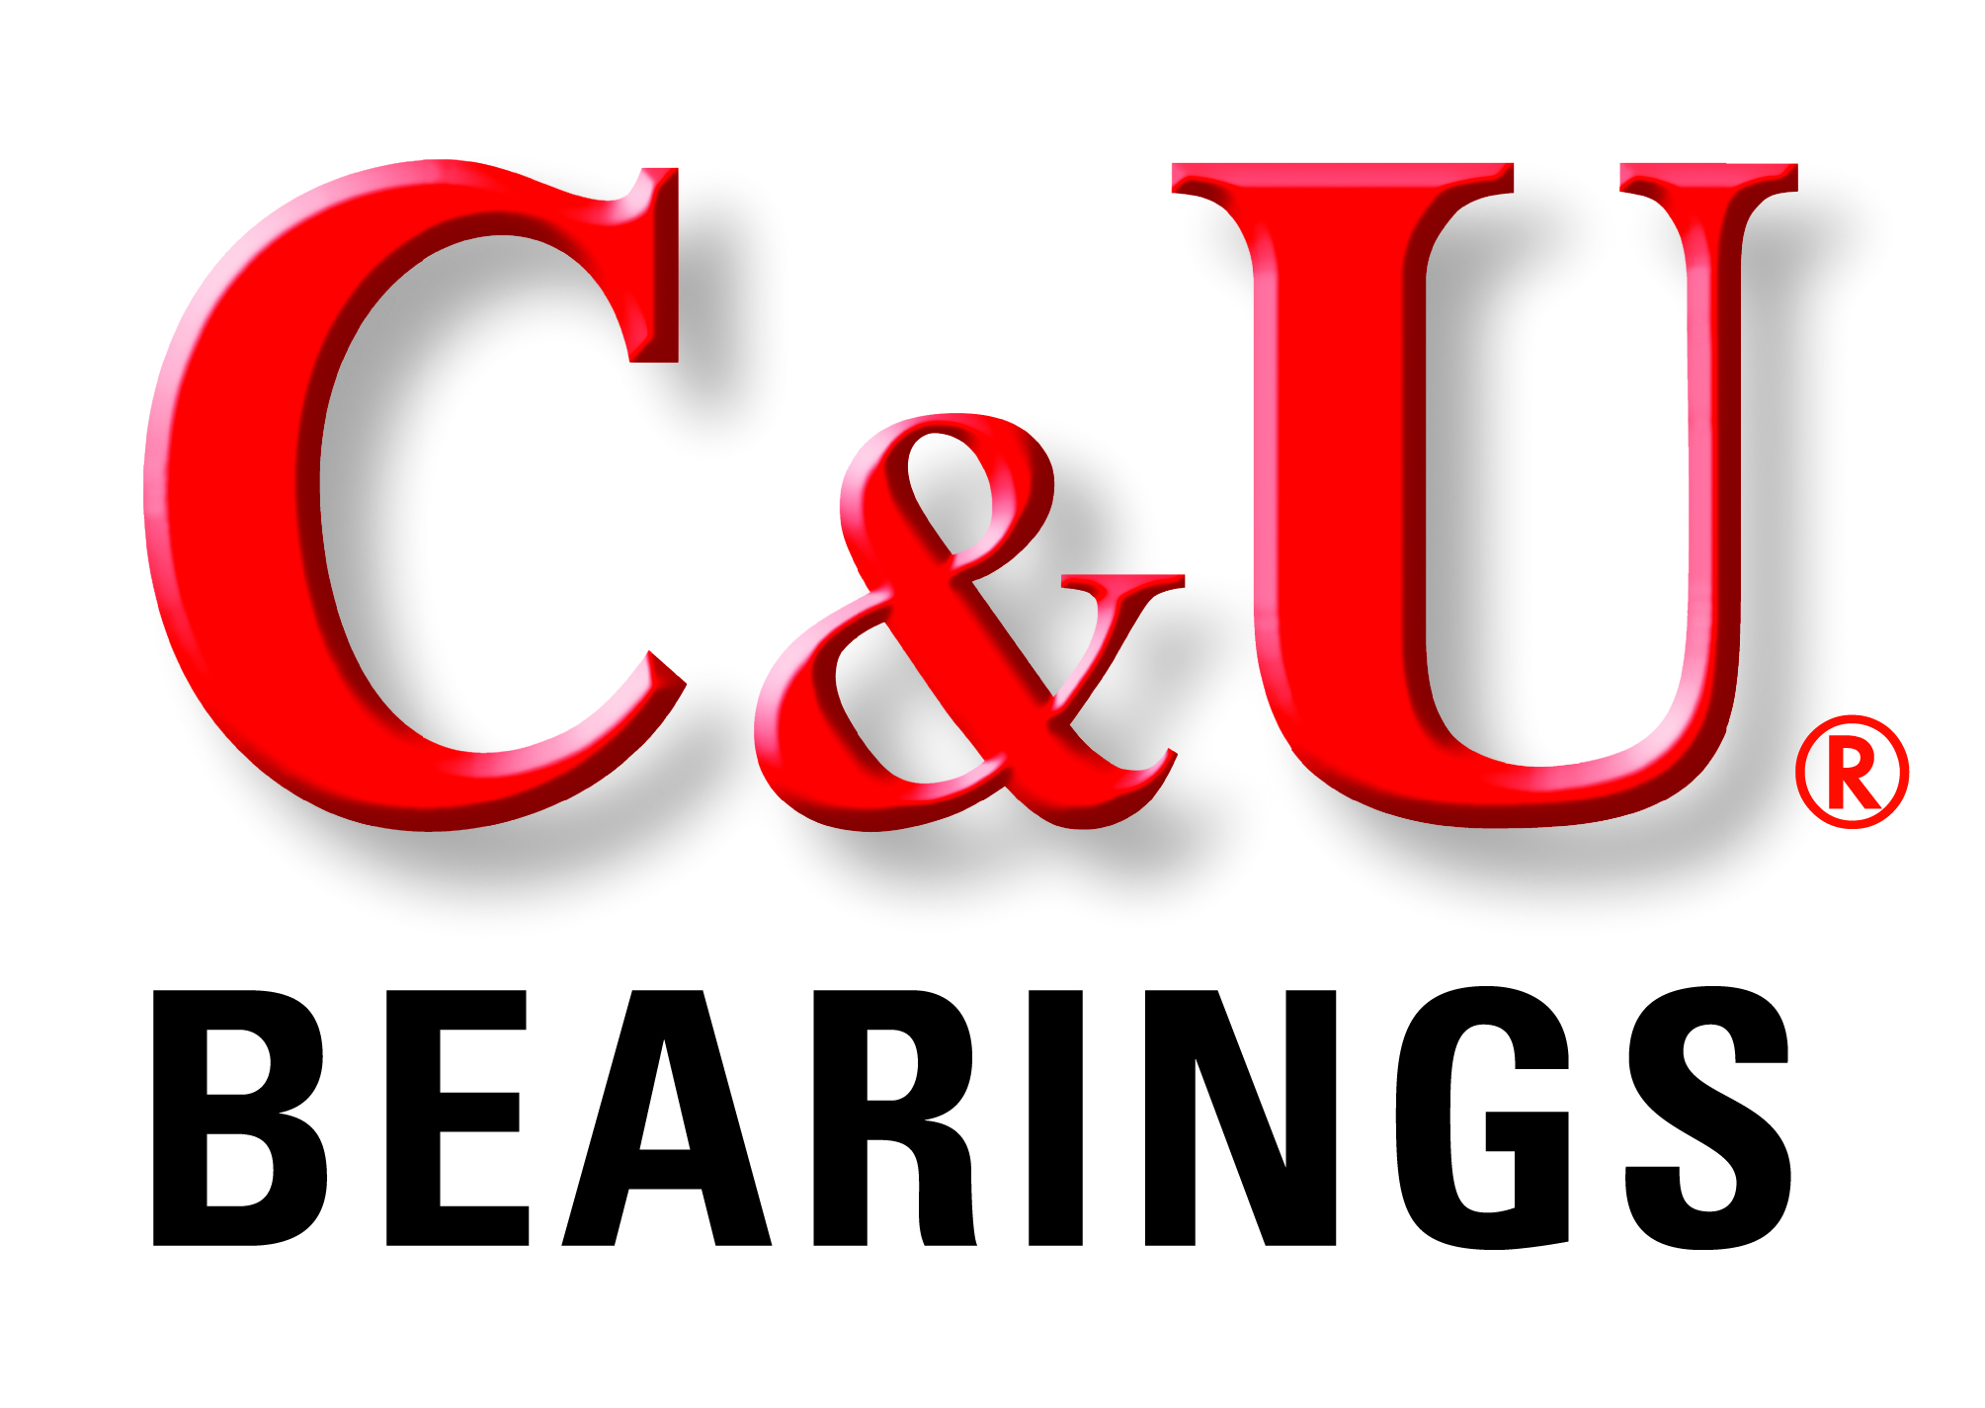

FOR: C&U Americas, LLC FOR IMMEDIATE RELEASE
45901 Five Mile Road
Plymouth, MI 48170
Contact: Dave Marek
734-656-0260 ex 228

C&U Americas Tapered Roller Bearings Deliver High Performance Under Heavy Radial and Axial Loads

- Versatile performance under heavy loads, many applications, relatively small package-

Plymouth, MI… C&U Americas, LLC, the North American subsidiary of the C&U Group, one of the world’s top 10 bearing manufacturers and China’s largest bearing producer, offers versatile, world-class quality tapered roller bearings for use in an extensive range of challenging applications. The bearings are precision made to the highest quality standards, and are more affordably priced than most competitive bearings.

C&U tapered roller bearings are suitable for various automotive applications including wheel ends, transmissions, transfer cases, axles and differentials.

Specifically designed to deliver key product performance features, C&U Americas tapered roller bearings are available in both inch series and metric design configurations based on application needs. C&U bearings are manufactured to the strictest quality standards and feature superfinished raceways, which help to ensure long lasting operation. These versatile bearings perform under a wide range of loads, duty cycles, and temperature conditions.

C&U Americas offers a full line of bearing types and styles for use in original equipment manufacturing, aftermarket replacement, and MRO operations. The C&U portfolio includes over 30,000 types of bearings in a wide range of specifications and sizes ranging from 1.5mm ID to 4000mm OD.

Over 930 million high-quality bearings are annually produced from C&U’s seven major bearing manufacturing centers, 36 bearing plants, and 18 vertically integrated component plants. Each of the manufacturing centers is independently certified for ISO9001 Quality Management Systems, QS9000/VDA6.1 Quality Management Systems, ISO14001 Environmental Management Systems, and ISO/TS 16949 Quality Management Systems.

From its North American headquarters in Plymouth, Michigan, C&U Americas is able to offer its NAFTA customers exceptional value along with complete application engineering and customer service support.

For more information, contact David Marek, C&U Americas, 45901 Five Mile Road Plymouth, MI 48170, Tel: 734-656-0260 ex 228 or visit: cubearing.com
Email: david.marek@cubearing.com

Image file: CU Tapered roller bearing.jpg
Caption: C&U Americas world-class tapered roller bearings feature versatile performance under a wide range of heavy loads, duty cycles and temperature conditions.

# # #

94-17/CU303

