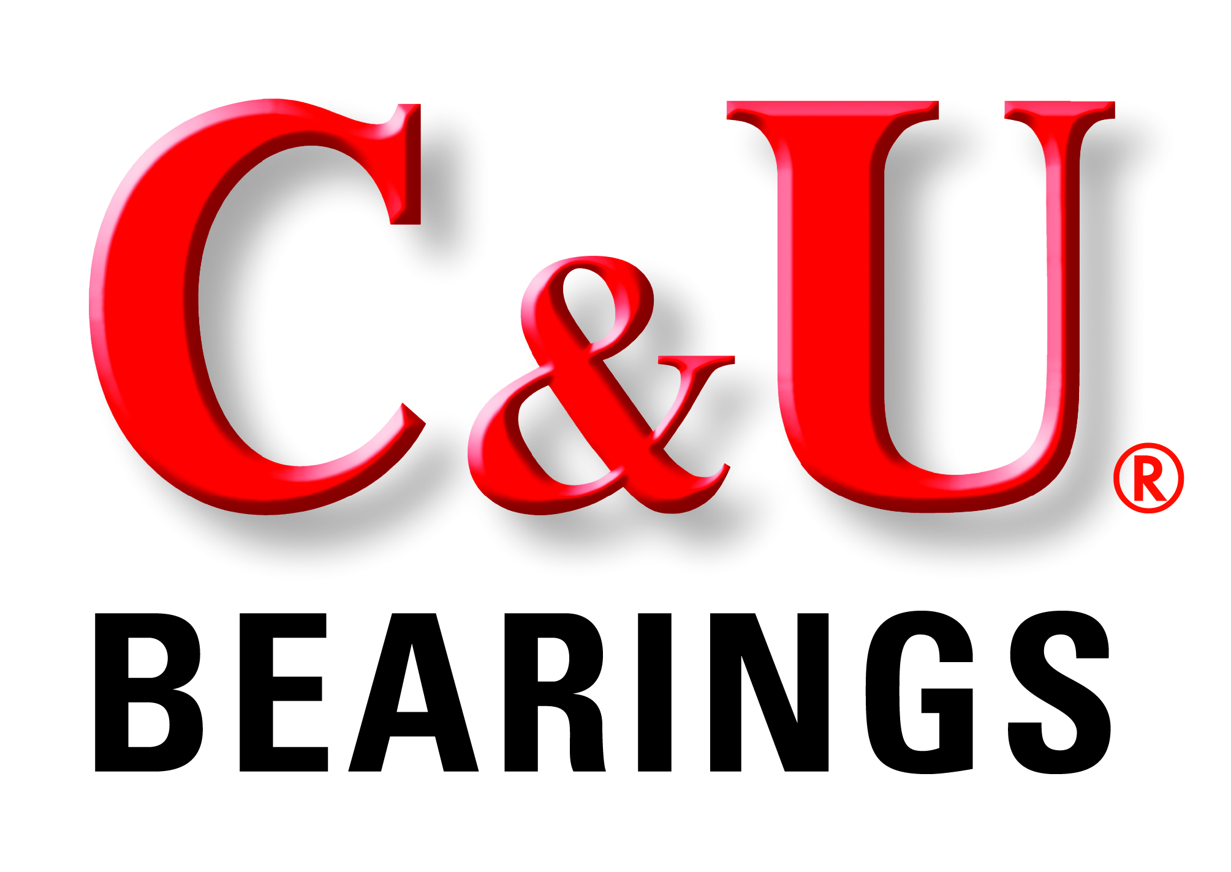

FOR: C&U Americas, LLC FOR IMMEDIATE RELEASE
45901 Five Mile Road
Plymouth, MI 48170

Contact: Dave Marek
734-656-0260 ex 228

Hitachi Automotive Systems Presents 2015 Quality Excellence Award to C&U Americas

Plymouth, MI… C&U Americas, LLC, the North American subsidiary of The C&U Group, one of the world’s top 10 bearing manufacturers and China’s largest bearing producer, was honored with the 2015 Quality Excellence Award by Hitachi Automotive Systems Americas, Inc. The award was presented in recognition of outstanding quality performance achievement. C&U Americas President, Thomas Rouse, and C&U Americas Director of Engineering, Richard Peterson, accepted the award during the 5th Annual Hitachi Automotive Systems Supplier Conference in Richmond, KY.

The announcement was made by Hitachi Automotive Systems Americas, Inc. Vice President Corporate Procurement, Steve Meadows, who noted, “Hitachi is fortunate to work with a supplier partner such as C&U Americas, who is keenly focused on providing unmatched customer satisfaction and committed to consistently delivering the highest quality products possible.”

C&U Americas President, Thomas Rouse, added, “Receiving this Quality Excellence Award is a testament to the hard work of our team members and the quality products that have helped C&U earn its reputation as a global industry leader. We truly appreciate the recognition by Hitachi Automotive System for our efforts and commitment.”

Hitachi Automotive Systems Americas, Inc., a subsidiary of Hitachi America, Ltd., manufactures, remanufactures, and markets a wide range of automotive systems including engine management systems, electric power train systems, drive control systems, and car information systems for all major automotive original equipment manufacturers worldwide.

C&U Americas offers a full line of bearing types and styles for use in original equipment manufacturing, aftermarket replacement, and MRO operations. The C&U portfolio includes over 30,000 types of bearings in a wide range of specifications and sizes ranging from 1.5mm ID to 4000mm OD.

As China’s largest bearing producer and one of the world’s top 10 bearing manufacturers, C&U utilizes the formidable production capabilities of its nine bearing manufacturing centers, 36 bearing plants, and 18 vertically integrated component plants to reach an annual production capacity of 819 million units.

C&U Bearings are precision made in advanced manufacturing facilities that are independently certified for ISO9001 Quality Management System, QS9000/VDA6.1 Quality Management System, ISO14001 Environmental Management System and ISO/TS16949: Quality Management Systems.
From its North American headquarters in Plymouth, Michigan, C&U Americas is able to offer its NAFTA customers exceptional value along with complete application engineering and customer service support.

For more information, visit: cubearing.com or contact David Marek, C&U Americas, 45901 Five Mile Road Plymouth, MI 48170, Tel: 734-656-0260 ex 228
Email: david.marek@cubearing.com

Reference image file C&U Rouse and Peterson Accept Quality Award.jpg

Caption:
Presentation of the 2015 Quality Excellence Award from Hitachi Automotive Systems Americas, Inc. (L to R) Jorge Villalobos -Purchasing General Manager of Hitachi Automotive Systems, Steve Meadows - Vice President Corporate Procurement of Hitachi Automotive Systems, Richard Peterson - Director of Engineering, C&U Americas, Thomas Rouse - President of C&U Americas, and Paul Carroll - President and CEO of Hitachi Automotive Systems.

# # #

164-16/CU291

Caption for side bar only:

Presentation of the 2015 Quality Excellence Award from Hitachi Automotive Systems Americas, Inc. (L to R) Jorge Villalobos -Purchasing GM (Hitachi), Steve Meadows - VP Corporate Procurement (Hitachi), Richard Peterson - Director of Engineering (C&U), Thomas Rouse - President (C&U), and Paul Carroll - President and CEO (Hitachi).

